**Lab 10**

**10_SIP Server Configuration**

We assigned an IP address of 192.168.1.10 to the PC and connected the route by entering 192.168.1.1 into the address bar.

We enabled wireless, changed the SSID to GladosCake and set up authentication for the network.

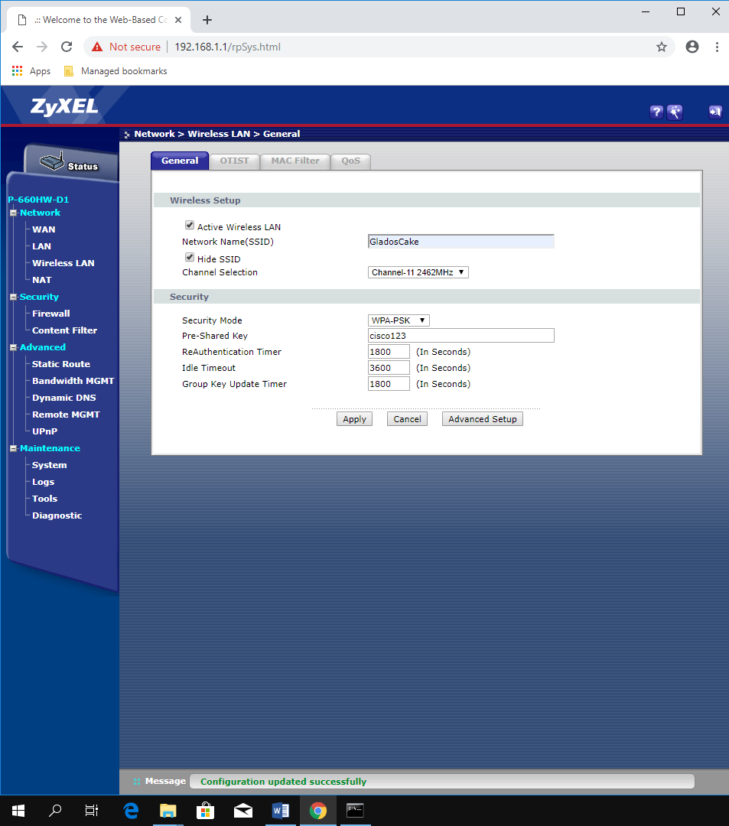

We enabled the DCHP server and set up a DHCP pool from 192.168.1.100 to 192.168.1.200.

We connected to the network using a phone.

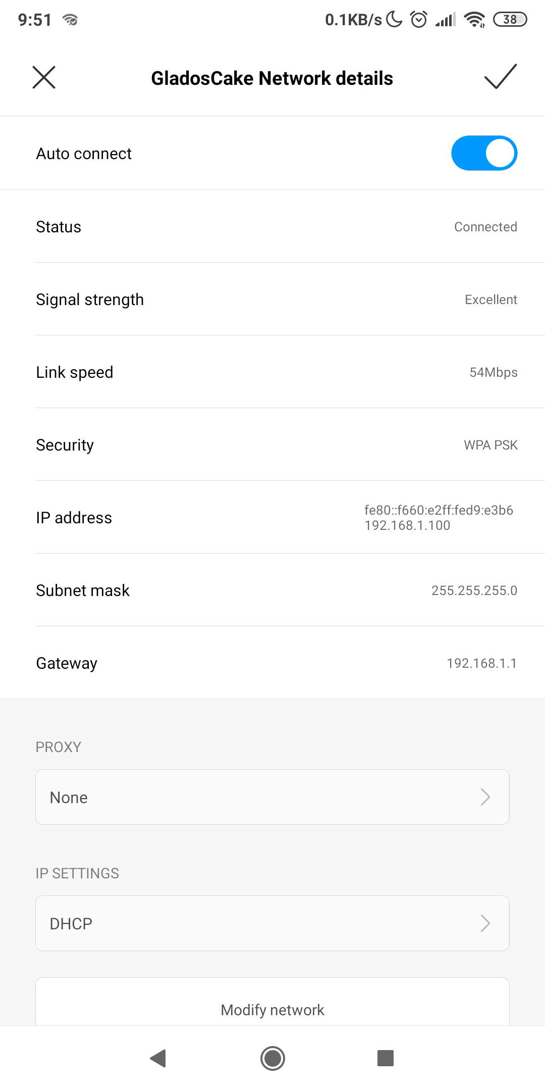

We set up the MAC filter using the MAC address of the phone.

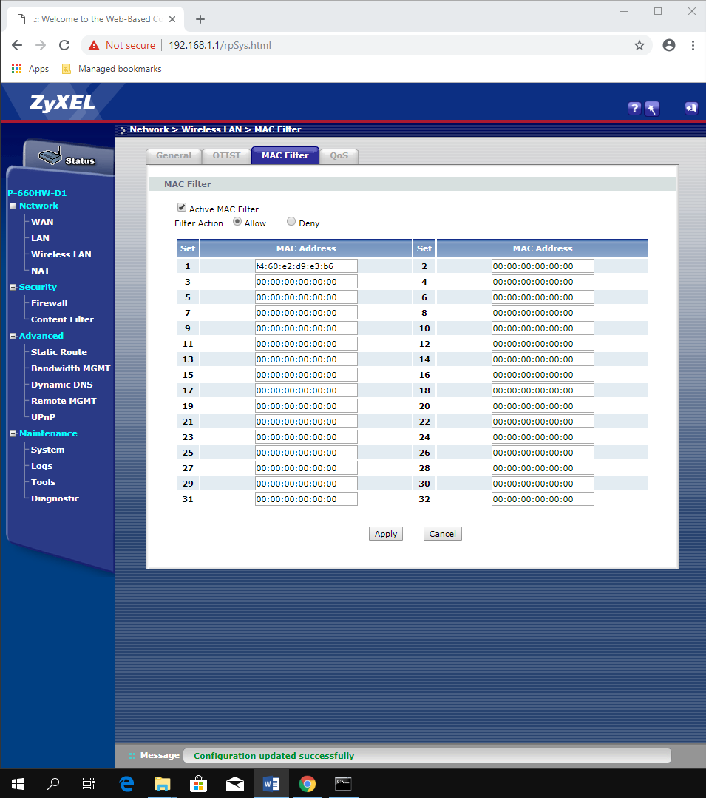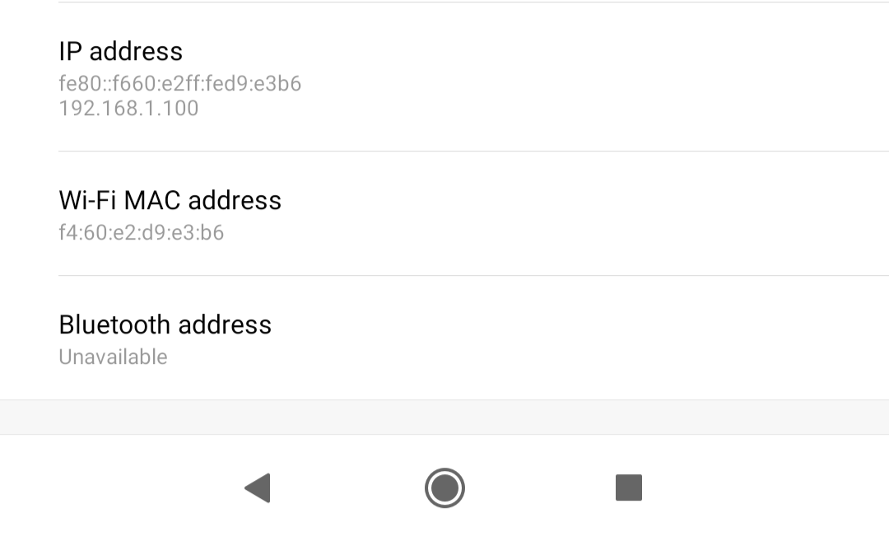

We could not use advanced option using this router.